LAB IMPLEMENTATION EXPERIMENT 9
Retrieval-Augmented Generation (RAG) for Document Question Answering
Generative AI Laboratory (CO1, CO2)
Aim
To develop a document-grounded question-answering pipeline that extracts BattingCoach project information, chunks and embeds the text, retrieves relevant evidence using FAISS and supplies that evidence to a language model for answer generation.
Theory
Retrieval-Augmented Generation (RAG) combines information retrieval with text generation. Instead of relying only on a model’s internal parameters, the system first searches a supplied document corpus and places the retrieved passages into the generation prompt.
The main components are a document loader, text splitter, embedding model, vector store, retriever, prompt builder and generative model. Document chunks are embedded and indexed. A user question is embedded with the same model, and the nearest chunks are selected using top-k similarity search.
A grounded RAG prompt separates context from the question and instructs the model to answer only from the supplied evidence. It should explicitly require the model to state when the documents do not contain enough information. The system should show source filenames or chunk IDs so the answer can be checked. Retrieval relevance and answer correctness must be evaluated separately.
Dataset note: the source corpus is built from public BattingCoach repository documentation, including README.md, README.dataset.txt, README.roboflow.txt, data.yaml and selected technical descriptions from the Python source. The repository states that the Roboflow bat dataset contains 930 images with YOLOv8 oriented-box annotations. Only public technical facts are used; no private athlete information is included.
Steps
1. Install Sentence Transformers, FAISS, Transformers and PyTorch.
2. Prepare a source-labelled corpus from BattingCoach documentation. Preserve each file or section as source metadata.
3. Extract readable text and split long documents into chunks. Assign a unique source/chunk ID to each segment.
4. Generate embeddings for every chunk using all-MiniLM-L6-v2 or another approved model. Record the embedding dimension.
5. Create a FAISS index and implement a retriever that returns the top three relevant chunks for a query.
6. Build a RAG prompt that clearly separates the retrieved context from the user question and instructs the model not to invent facts.
7. Load an approved compact instruction model if the runtime has sufficient resources. If it cannot be loaded, show retrieval evidence and mark the generation stage as unavailable rather than fabricating an answer.
8. Test at least six questions: three answerable questions, one paraphrase, one multi-part question and one question whose answer is absent from the corpus.
9. For every test, record the answer, source IDs, retrieval relevance, answer support and hallucination observations. Compare at least one question with and without retrieved context if possible.
Code
Core implementation excerpt (the complete runnable workflow is provided in the corresponding notebook).
%pip -q install sentence-transformers faiss-cpu transformers torch
from sentence_transformers import SentenceTransformer
import numpy as np, faiss
docs = [
("README.md#overview", "MediaPipe estimates 3D joint positions and kinematic angles."),
("README.md#shadow", "Shadow practice suppresses bat-specific YOLO checks."),
("README.md#willow", "Live willow practice uses YOLOv8-OBB for blade angle and bat-pad gap."),
("README.roboflow.txt", "The bat dataset contains 930 YOLOv8-OBB annotated images."),
("data.yaml", "The dataset has train, valid and test splits and one class named Bat.")
]
embedder = SentenceTransformer("sentence-transformers/all-MiniLM-L6-v2")
texts = [d[1] for d in docs]
vecs = embedder.encode(texts, normalize_embeddings=True).astype("float32")
index = faiss.IndexFlatIP(vecs.shape[1]); index.add(vecs)
def retrieve(question, k=3):
q = embedder.encode([question], normalize_embeddings=True).astype("float32")
scores, ids = index.search(q, k)
return [(docs[i][0], docs[i][1], float(s))
for s, i in zip(scores[0], ids[0])]
def build_prompt(question, hits):
context = "\n".join(f"[{src}] {txt}" for src, txt, _ in hits)
return ("Answer only from the context. If information is absent, say so.\n"
f"CONTEXT:\n{context}\nQUESTION: {question}\nANSWER:")
Output
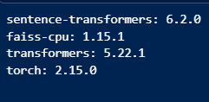

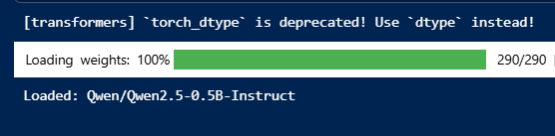

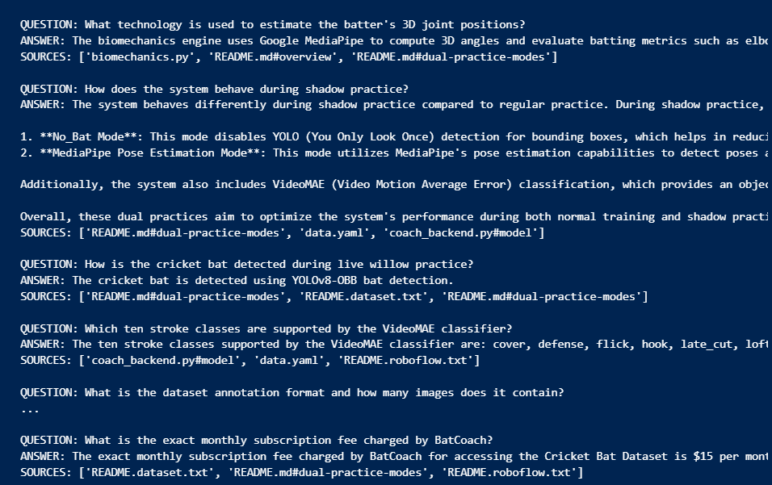

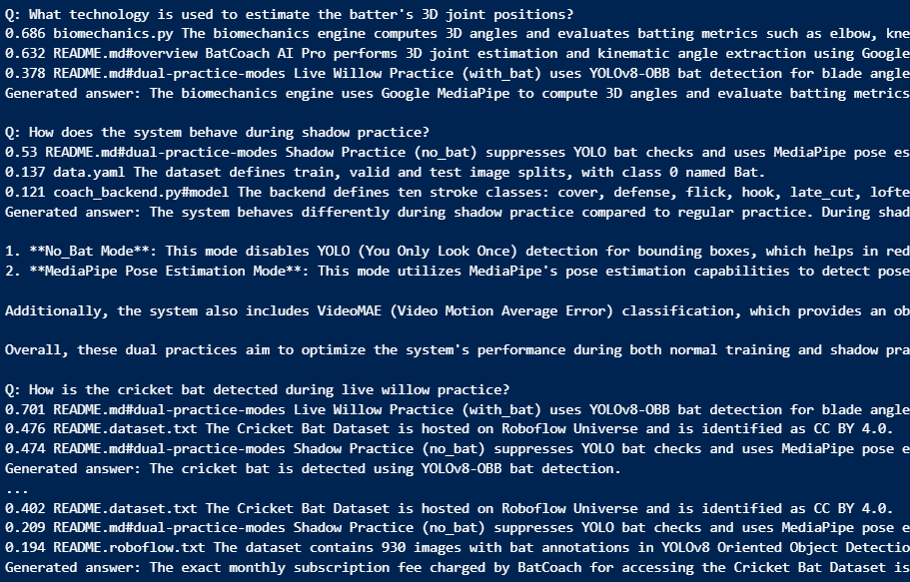

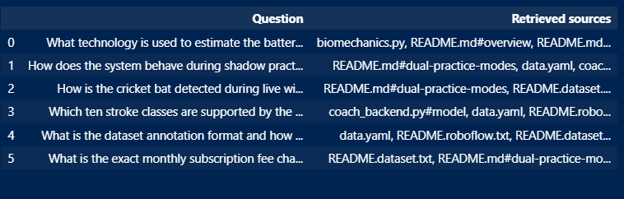

Observation
For every question, record whether the top-k chunks are relevant and whether each answer claim is supported by those chunks. Discuss paraphrase retrieval, multi-chunk evidence, source traceability and how the system handled the out-of-corpus question. Distinguish retrieval failures from generation hallucinations.
Conclusion
The experiment demonstrates a RAG pipeline in which relevant BattingCoach documentation is retrieved before an answer is generated. Its usefulness depends on document preparation, embedding quality, top-k retrieval and faithful use of the supplied context. Complete the conclusion using the six actual test cases, especially the out-of-corpus response and source traceability.

